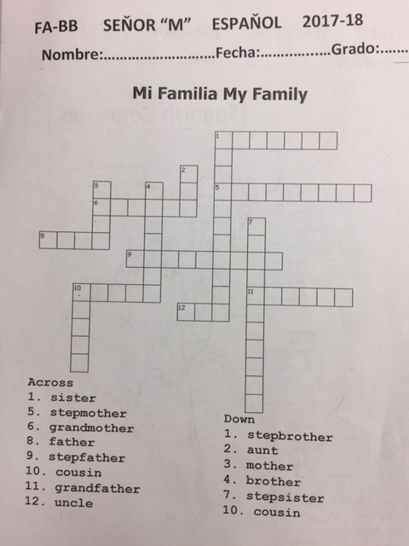
Instructions: Translate the vocab. and solve the puzzle in Spanish.
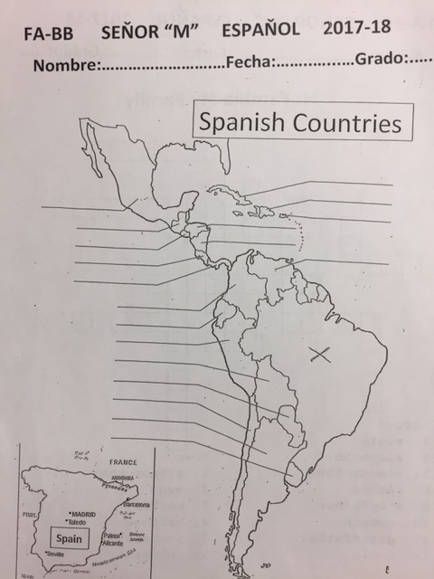
Instructions: Write the Spanish countries and color the map.

