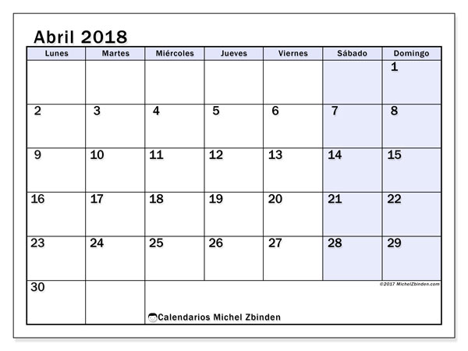
Directions: Construct a calendar for the month of April. Just like this one, but you need to add the numbers in Spanish.

