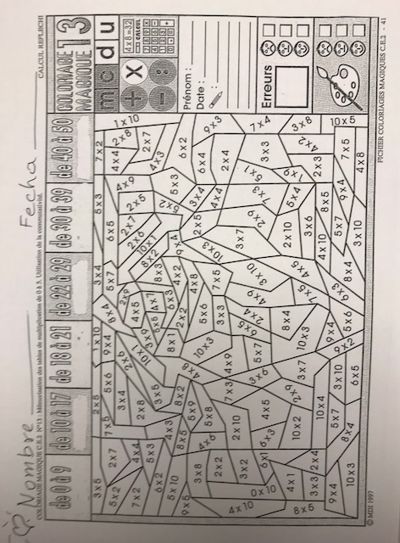
Directions: Multiply first. Then, write the Spanish color on the space and color the responses.

