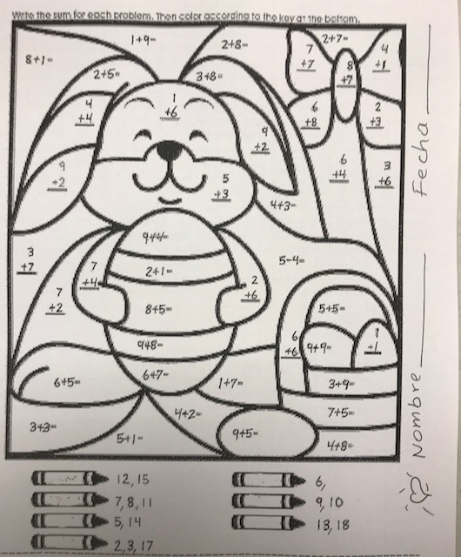
Direction. Add first. Then, write the Spanish color of your choice on the crayon and color it.

