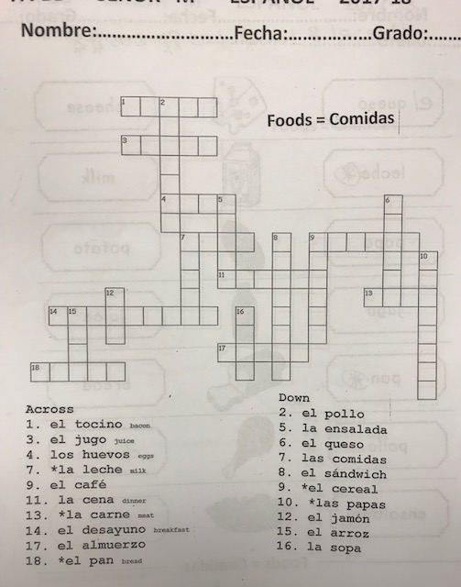
Directions: 1st and 2nd graders can do only across and some more if able. 3rd, 4th, and 5th graders should be able to find definitions on Google and solve the puzzle.

