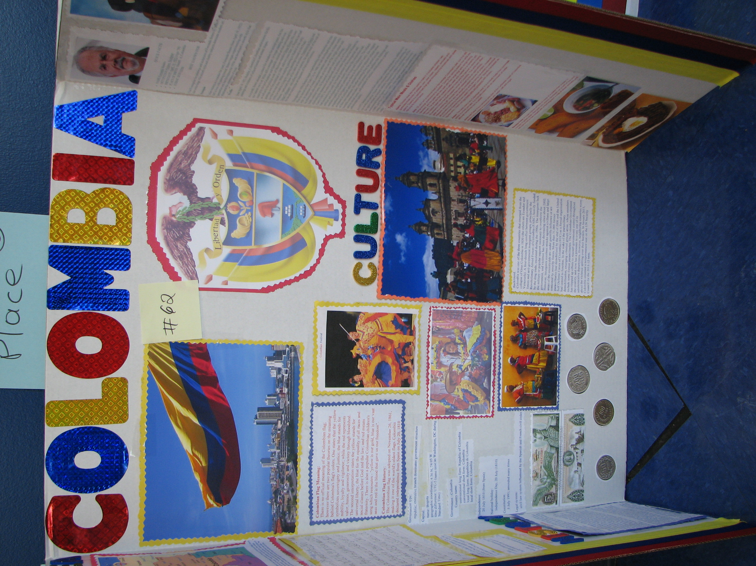
For this Project you need to pick a Spanish country and decide what you want to talk about: food, clothing, money, music, languages, or a mix of culture aspects, etc. This project can be made on any size paper or board.

