Instructions: Translate the vocab. and solve the puzzle in Spanish.

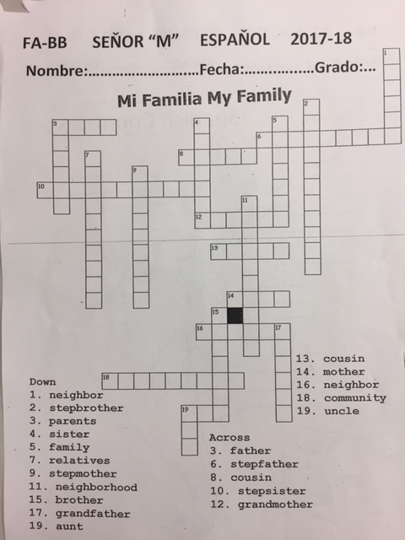

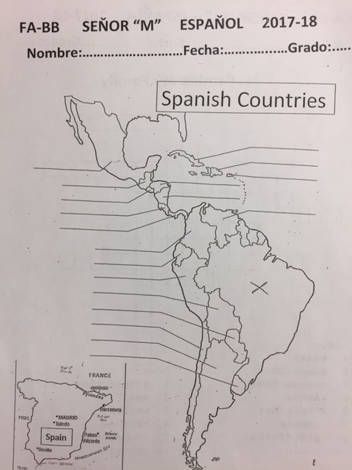
Instructions: Write the Spanish countries and color the map.

